CIVE202 SPRING 2026
Project 5: The Water Project
Aaron Cardinale
Contents
CIVE202 SPRING 2026 1
Introduction 2
Objectives 3
Methods 3
Results 3
Bias and Ethics 6
References 7

Introduction
Access to clean water is a basic human right, and still a major issue in underdeveloped countries. The Water Project works to bring drinking water to countries globally, but this project focuses on Sub-Saharan Africa. To be as efficient with resources as possible. The WP has hired our team to examine the JMP Household water dataset. This data set provides insight to drinking water access in households in 3 different settings, Urban, Rural, and Average. Our team chose data from 7 different countries in the region, and used python to compare their access in various ways. This report aims to help the WP in filling the gap of drinking water access for the most at need countries.

Objectives
- Analyze and display the JMP water access data for countries in Sub-Saharan Africa.

- Create 2 different summary figures showing water access over time, and water access across countries.

- Identify the regional differences in access to drinking water within Sub-Saharan Africa.

- Document the biases in coding choices to show how these choices influenced the final results

Methods
To efficiently complete the client requests, Python was used for data manipulation and display. data for Angola, Botswana, Congo, Guinea, Kenya, Niger, and Rwanda was gathered using the pandas library. We then made several cleaning choices to ensure accurate and workable data for our client. These Methods were determined through a need for completing the client’s request in an efficient, and complete manner: ensuring reliable workable data.

- Filtering: To create a fair comparison between countries. We focused on the “Total” water access for each country. This allowed us to more accurately complete the clients request for country to country comparison.

- Cleaning missing data: The dropna() function was used to remove any missing values.

- Creating a baseline: Because many countries were missing recent data. We decided to use 2020 to compare current access needs, Aswell as the gap to total access. This allowed us to create a fair environment through not displaying missing data, and using as much data as possible to display the clients request.

- Displaying Results: We used 2 different graphs to complete the client’s request. We used a time series plot to compare the 7 countries’ access over time. As well as a stacked bar chart displaying current access and the gap to total access.

Results
Differences in Access Across the Sub-Saharan Region
The analysis proves significant regional differences in the different countries of Sub-Sharan Africa. While most countries in the region face infrastructure issues, it is clear they do not all face them the same. For example, Botswana has had over 96% access for the duration of the study. On the other hand, Kenya has only 70% access, leaving almost 30% of the population without clean drinking water. This highlights the huge differences in the region, and shows the WP must dive deeper into further research to accurately fund the region. If funds are evenly distributed across nations, the ones that are most in need will not be able to overcome the defect they face. Funds must be distributed at an even deeper level for full effectiveness. Though all countries have made great progress in improved water access, some still have a long way to go.

Time Series Plot: Water Access Over Time
To fulfill one of the client’s main requests, A time series plot was created showing improved water access over time, compared across countries from the years 2000-2024. This figure cleanly displays the percentage of the population with improved water access on the Y-axis and the scope of study on the X-axis, each country is given a color to differentiate and analyze the graph. When focusing on change over time, we find that the region has had an overall positive trajectory for the past 20 years. Out of the 7 countries Botswana is the only one with adequate water access, proving infrastructure was developed long before 2000. The other 6 countries show an almost exact linear progression in water access. This shows the true difference lies in the countries’ starting point for water access. This Reinforces the WP current funding methodology by highlighting the similar improvements of access, while also showing where more aggressive funding is needed.
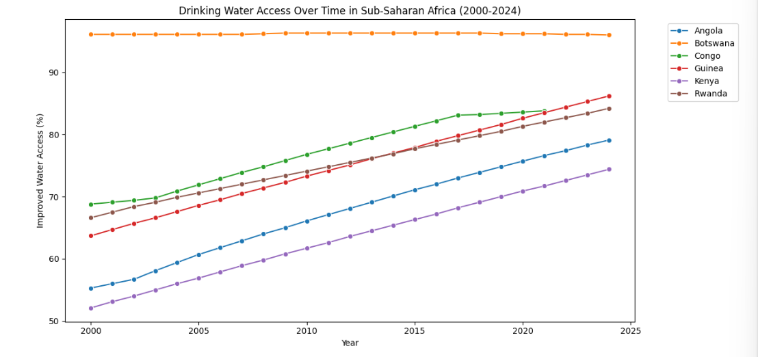

Summary Table and Stacked Bar Chart: Remaining need
To Address the clients second major request an interactive stacked bar chart was created to compare the different countries in a baseline sample. We chose 2020 as our baseline year as it had the most complete data. And then plotted the bar chart with current improved water access, as a percent, on the bottom. As well as the gap between the current access an total access highlighted in orange. This figure lets us better compare the countries on an even and current playing field to address the current gaps and need. inclusion of the gap to 100% lets the client clearly see the most necessary countries to help. This Final figure Shows the majority of resources must be allocated to Angola and Kenya. With both having over 1-5 people without clean drinking water, they are in urgent need of intervention.

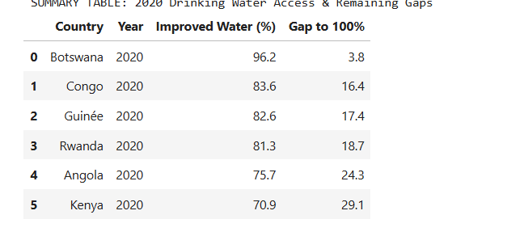
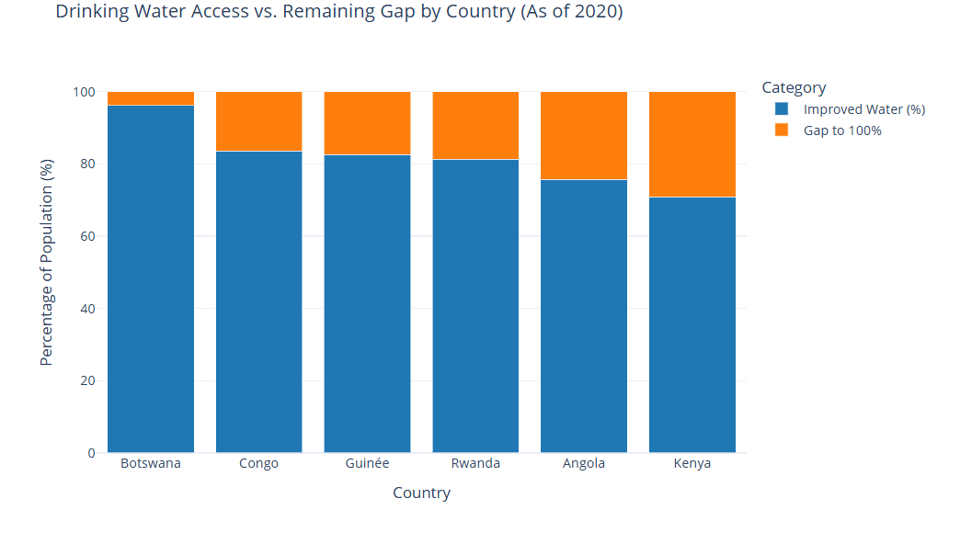

Conclusion
While the JMP dataset shows a positive trend in water access across the region, the progress remains highly uneven. Nations like Botswana have achieved almost full coverage for decades, while Angola and Kenya still face serious deficits that leave over one in five people without clean water. Therefore, our firm recommends the WP focus their funding and resource allocation to these highlighted nations. Though of this, Inherent bias in coding choices mean much more research into the specifics for struggling nations is needed. It is likely the situation in these low access countries is worse than displayed due to underreporting, and averaging. Overall, the WP should use our regional findings to do more research into Kenya and Angola to better address their current needs.

Bias and Ethics
Geographic Bias
For this project, we only imported data for seven countries. Sub-Saharan Africa has over 40 nations in just that region alone. Given that amount, we chose a mix of countries through research to cover as large a population as possible. Our code shows bias through not being able to show drinking water access over every country. This means a lot of data and people’s experiences are left out. This also raises an ethical concern whether the code is used as the end all be all for the WP’s decision making. The code is meant to prove that further research and investment is still needed overall in the region but cannot possibly pinpoint every location where that is true.

Urban vs Rural Bias
In our water_data function, we made a coding choice to filter the data using df['Setting'] == 'Total'. This creates an ethics bias because access is averaged over a country. The average hides the most suffering communities. Many of these nations are underdeveloped, meaning cities have more water access while rural areas deal with shortages. Since our goal was to compare access across countries the total number is skewed due to the population differences between urban and rural areas, possibly making the countries access level look better than reality.

Time Bias
Because the data from 2024 is not fully complete we chose to use 2020 as our basis for comparing drinking access at a static point. This makes the comparison fair for all countries, but also doesn’t display the most recent data. This may lead to the WP funding areas that have already received help, or mis representing areas that have lost development since that time.

Exclusion Bias
To make the data cleaner and for accurate graphs, the dropna() function was used. This function is incredibly useful for graphing because it takes missing values out from the data sets. Though it is necessary to prevent errors it also introduces ethical bias. The missing values could be due to countries not being able to properly collect and record data at that time. This could possibly lead the most at need countries to not be properly displayed due to less overall data then the rest of the countries.

References
“Data | JMP.” Washdata.org, 2018, washdata.org/data.
“The Water Project.” The Water Project, 2019, thewaterproject.org.

